Twitter Sandbox Registration

1. Create Twitter Account <https://twitter.com/i/flow/signup> and Login
2. Go to the <https://developer.twitter.com/en> and obtain the application for developers
3. For this you can go to the <https://developer.twitter.com/en/apply-for-access>



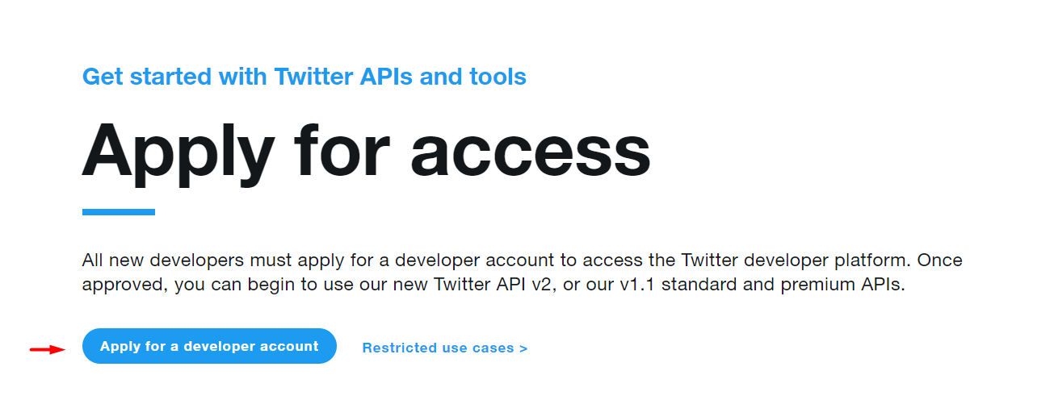

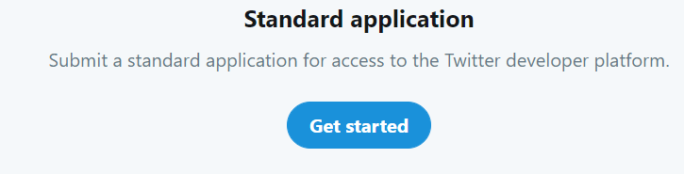

On all steps you have to enter detailed information. Also, you can receive email with additional questions about your application.

1. After registration was completed successfully in your dev portal you see next

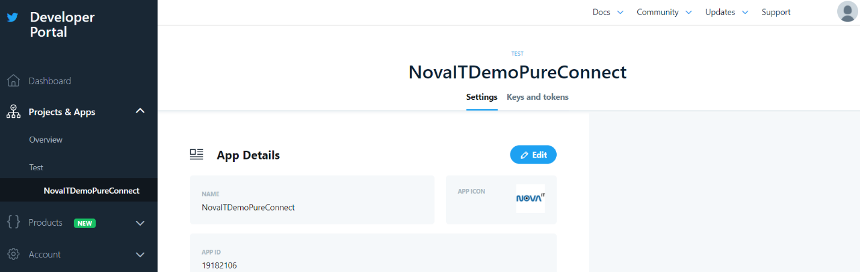

1. 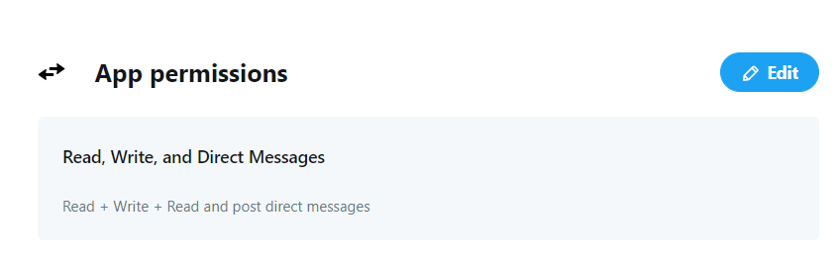Set permissions
2. In this functionality you can obtain

* API key
* API secret key
* Access token
* Access token secret

Send this token to us and we’ll send webhook back to you. Webhook must be entered into application settings in Twitter Dev portal.